Lab Exercise 6– Terraform Variables
Objective:
Learn how to define and use variables in Terraform configuration.
Prerequisites:
- Install Terraform on your machine.
Steps:
- Create a Terraform Directory:
- Create a new directory for your Terraform project.
mkdir terraform-variables
cd terraform-variables
- Create a Terraform Configuration File:
- Create a file named main.tf within your project directory.
# main.tf
resource "aws_instance" "myinstance-1" {
ami = var.myami
instance_type = var.my_instance_type
count = var.mycount
tags = {
Name= "My Instance"
}
}
- Define Variables:
- Open a new file named variables.tf. Define variables for region, ami, and instance_type.
# variables.tf
variable "myami" {
type = string
default = "ami-08718895af4dfa033"
}

variable "mycount" {

type = number
default = 5
}

variable "my_instance_type" {
type = string
default = "t2.micro"
}

Output:-
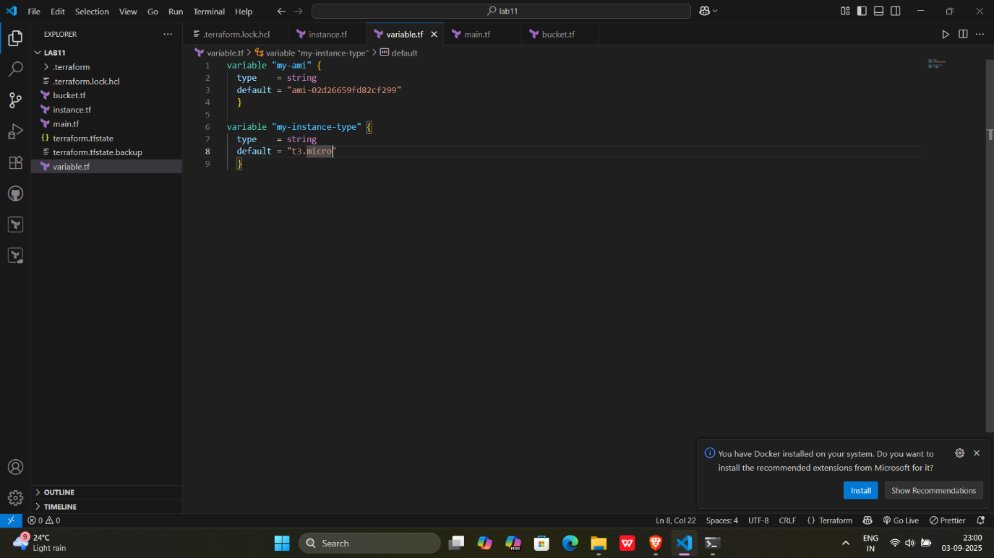

- Initialize and Apply:
- Run the following Terraform commands to initialize and apply the configuration.
terraform init
terraform plan
terraform apply -auto-approve
Observe how the region changes based on the variable override.

Output:-

Command - Terraform plan

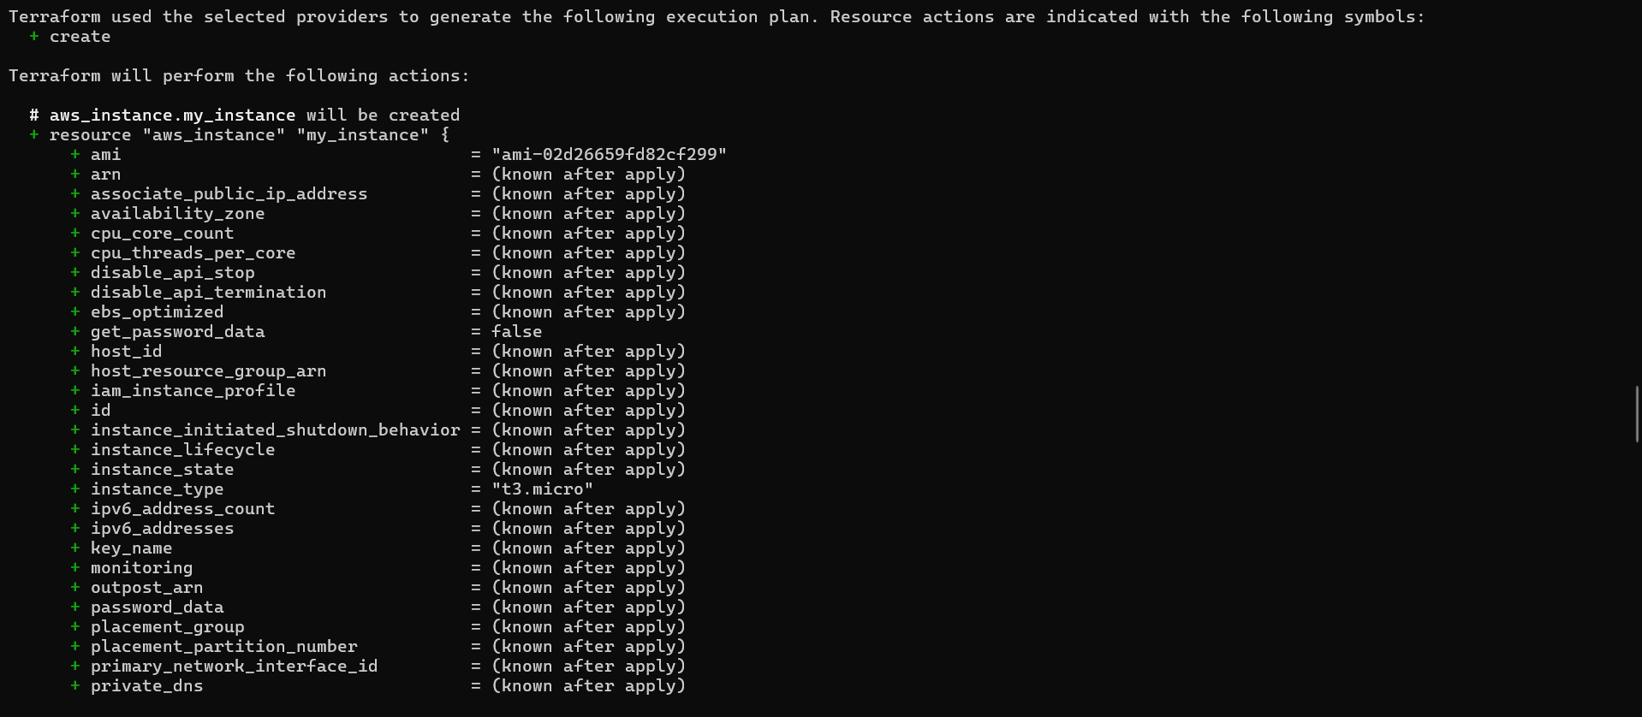
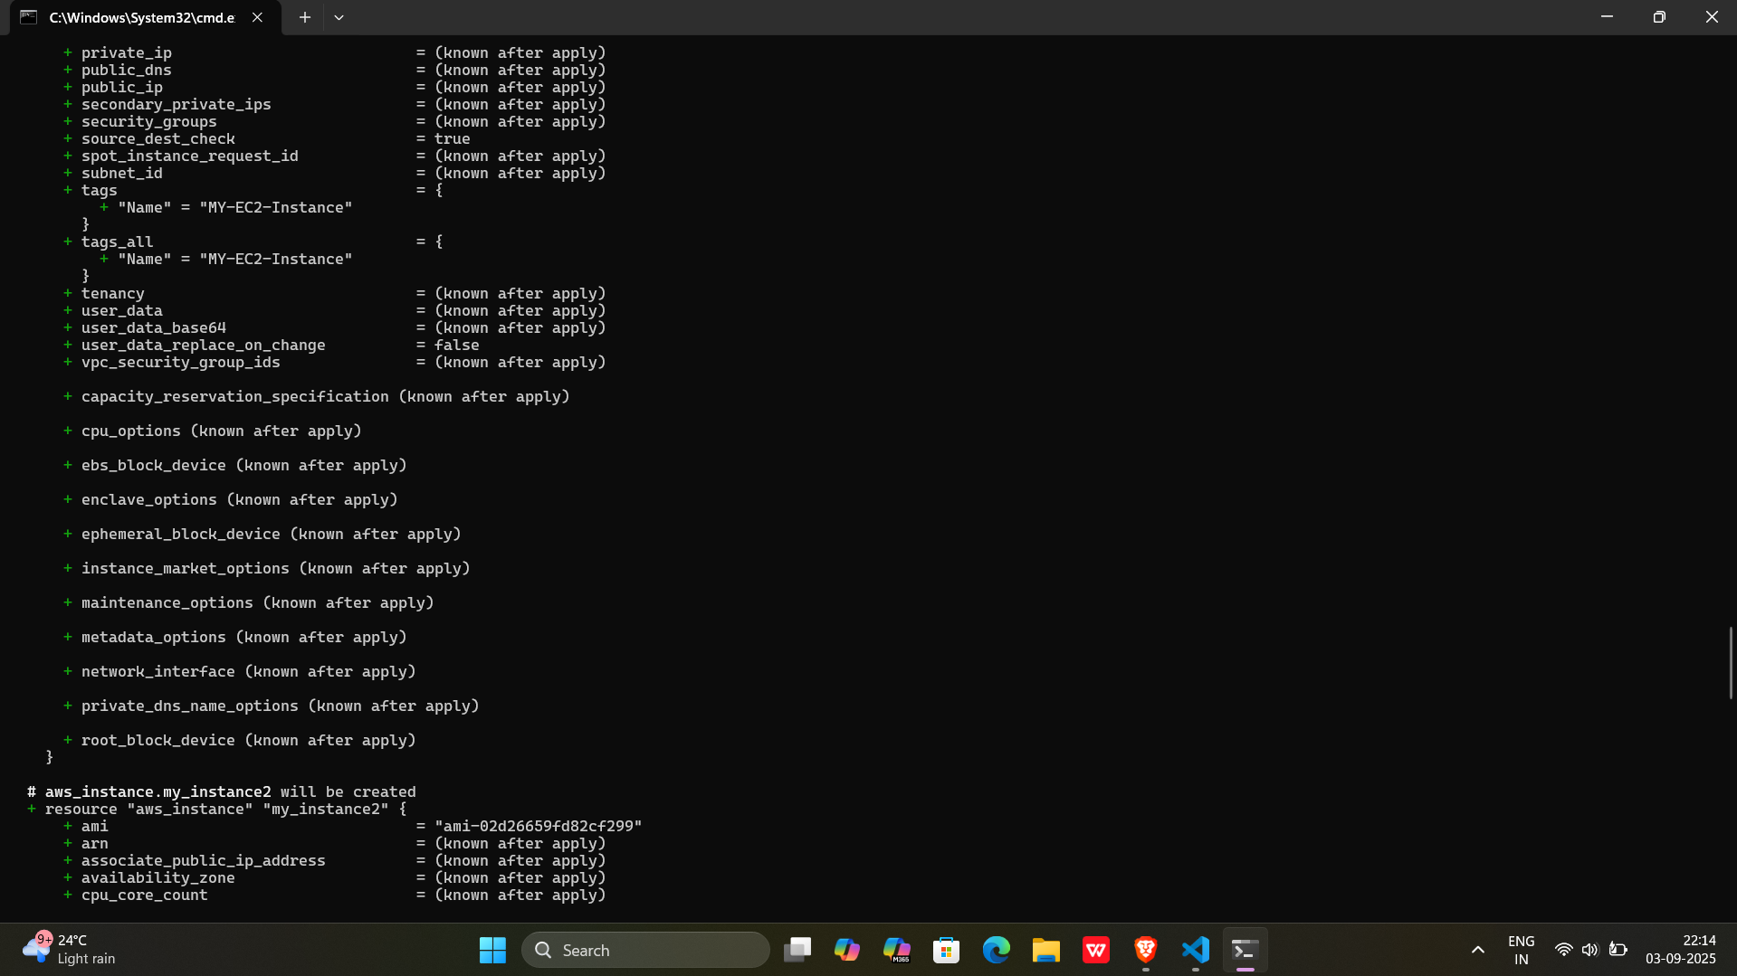
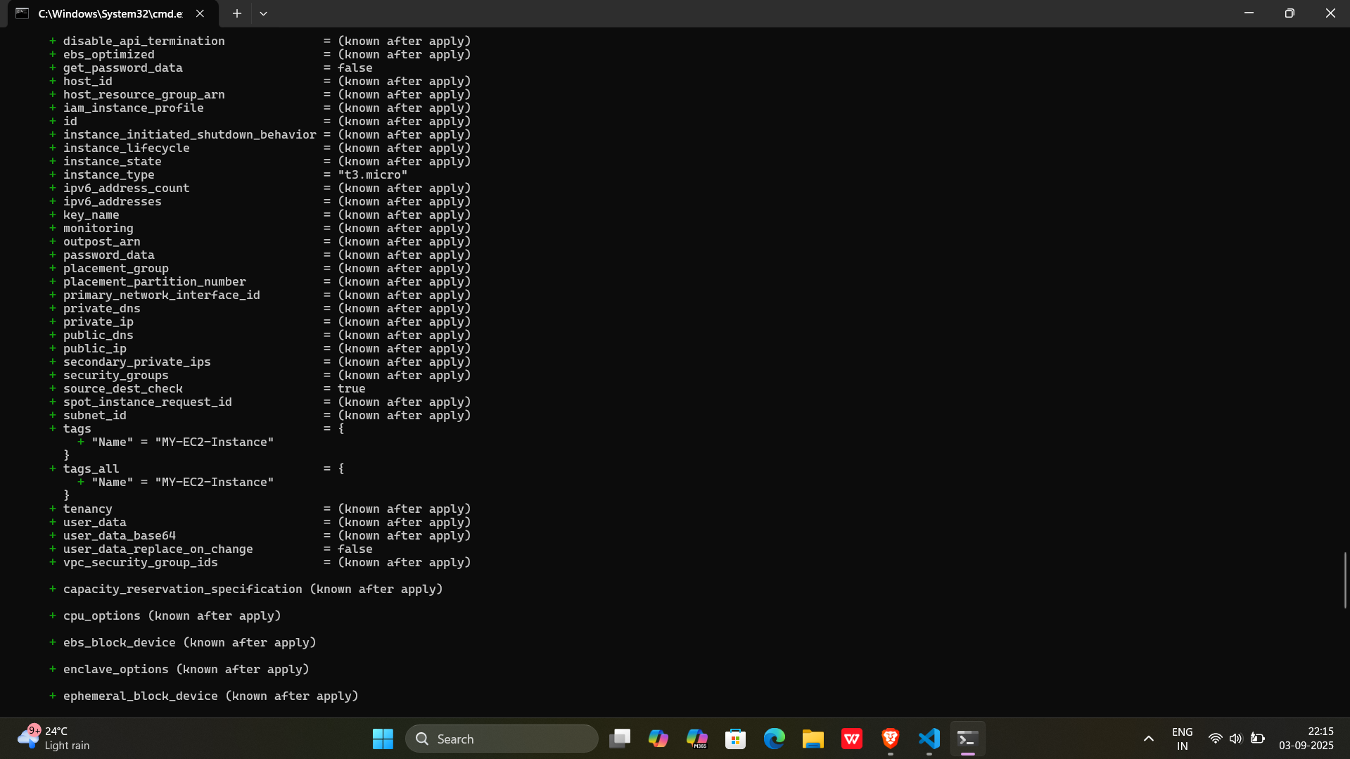
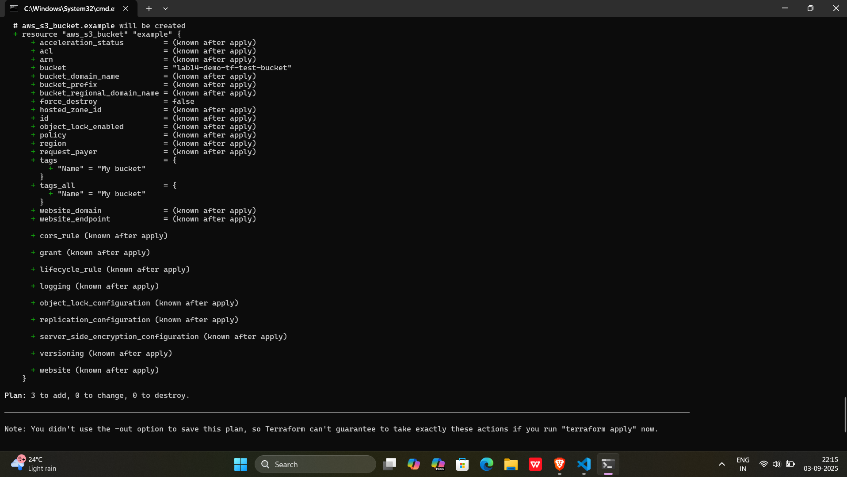
When (default = "t3.large") command- terraform plan
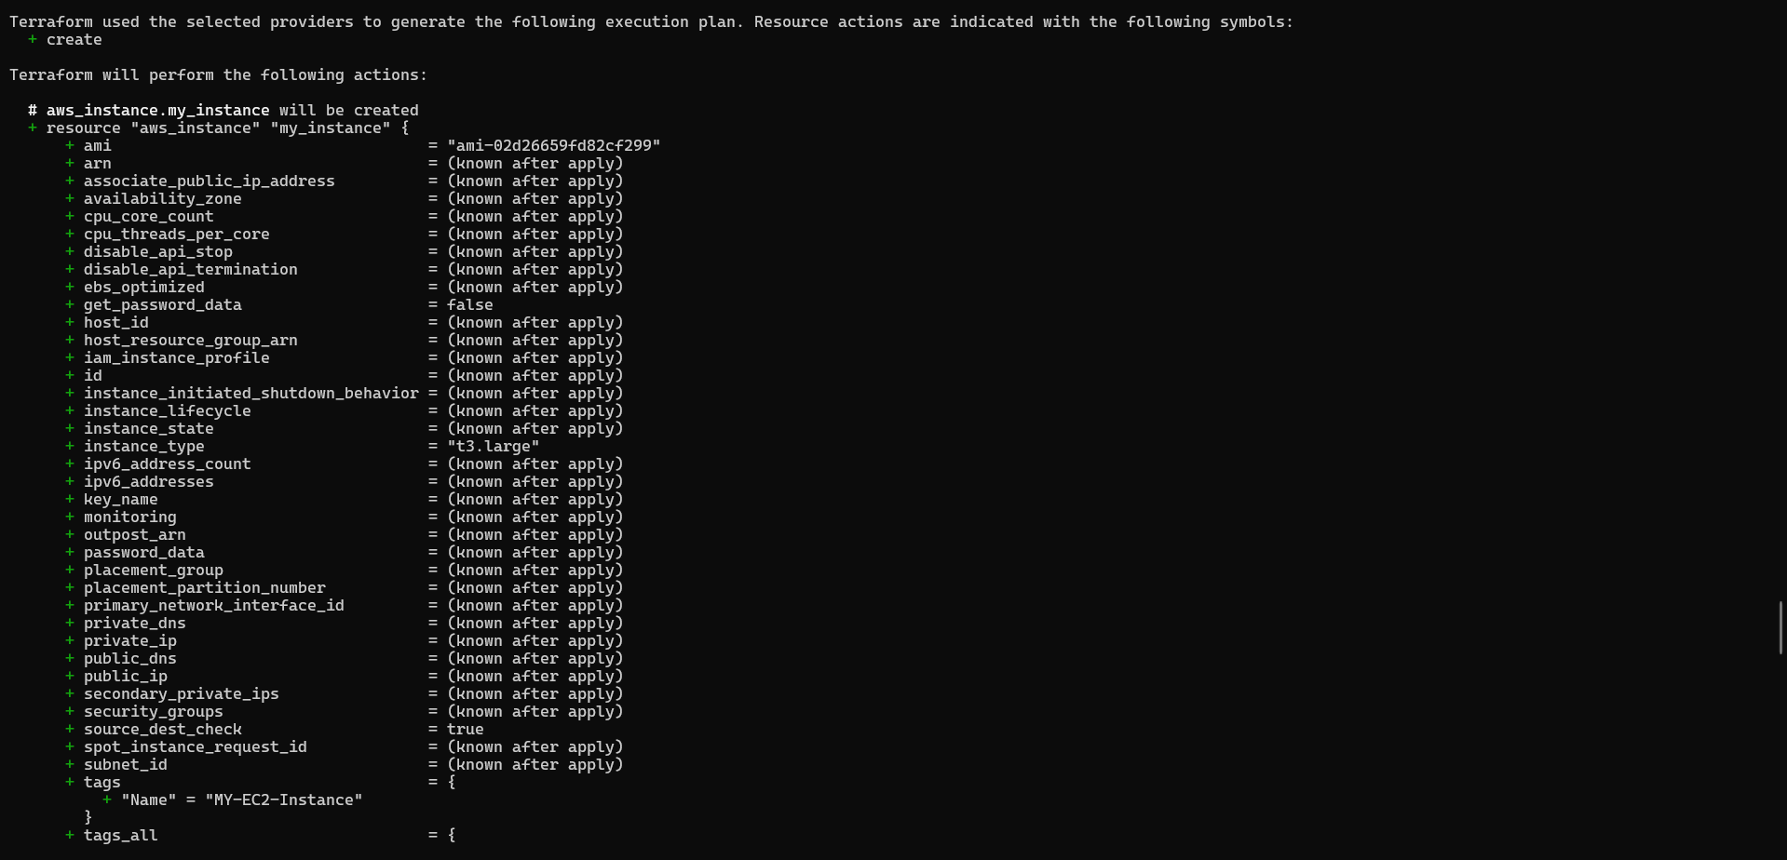
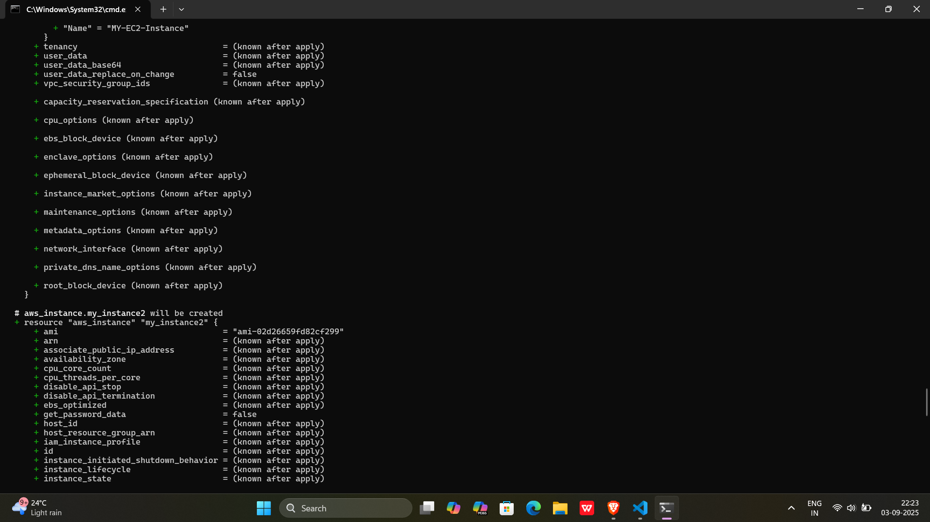
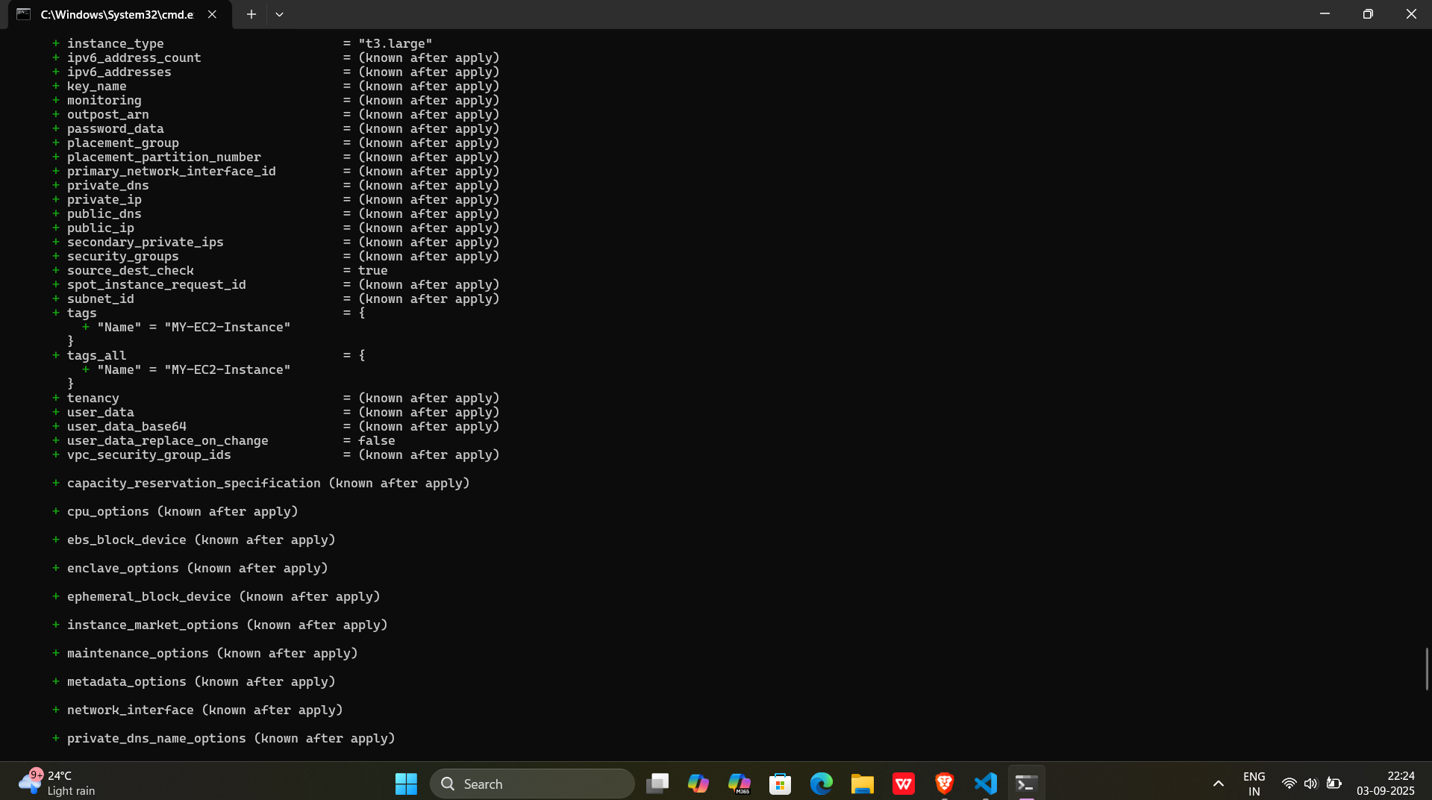

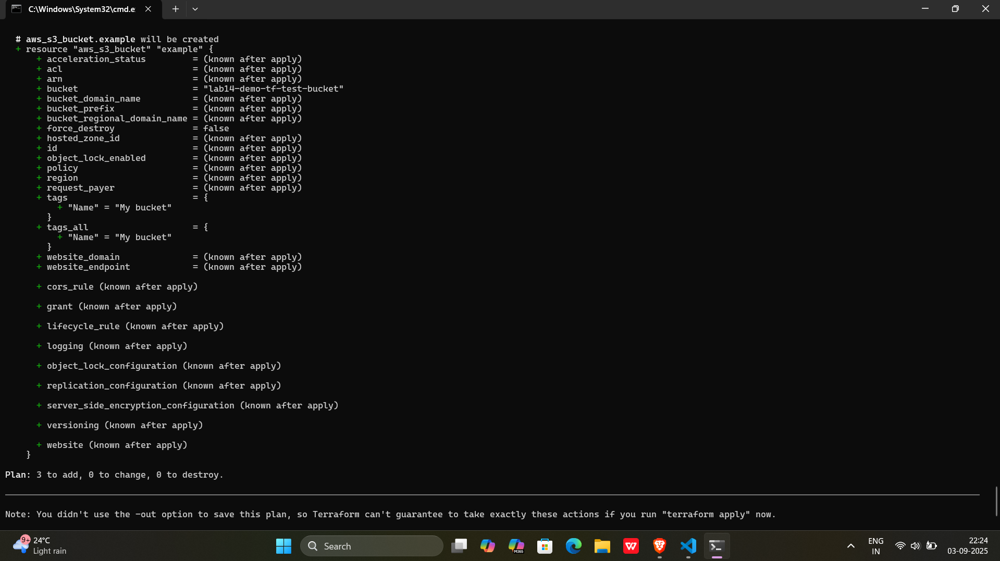
Runing terraform plan command after making variable.tf
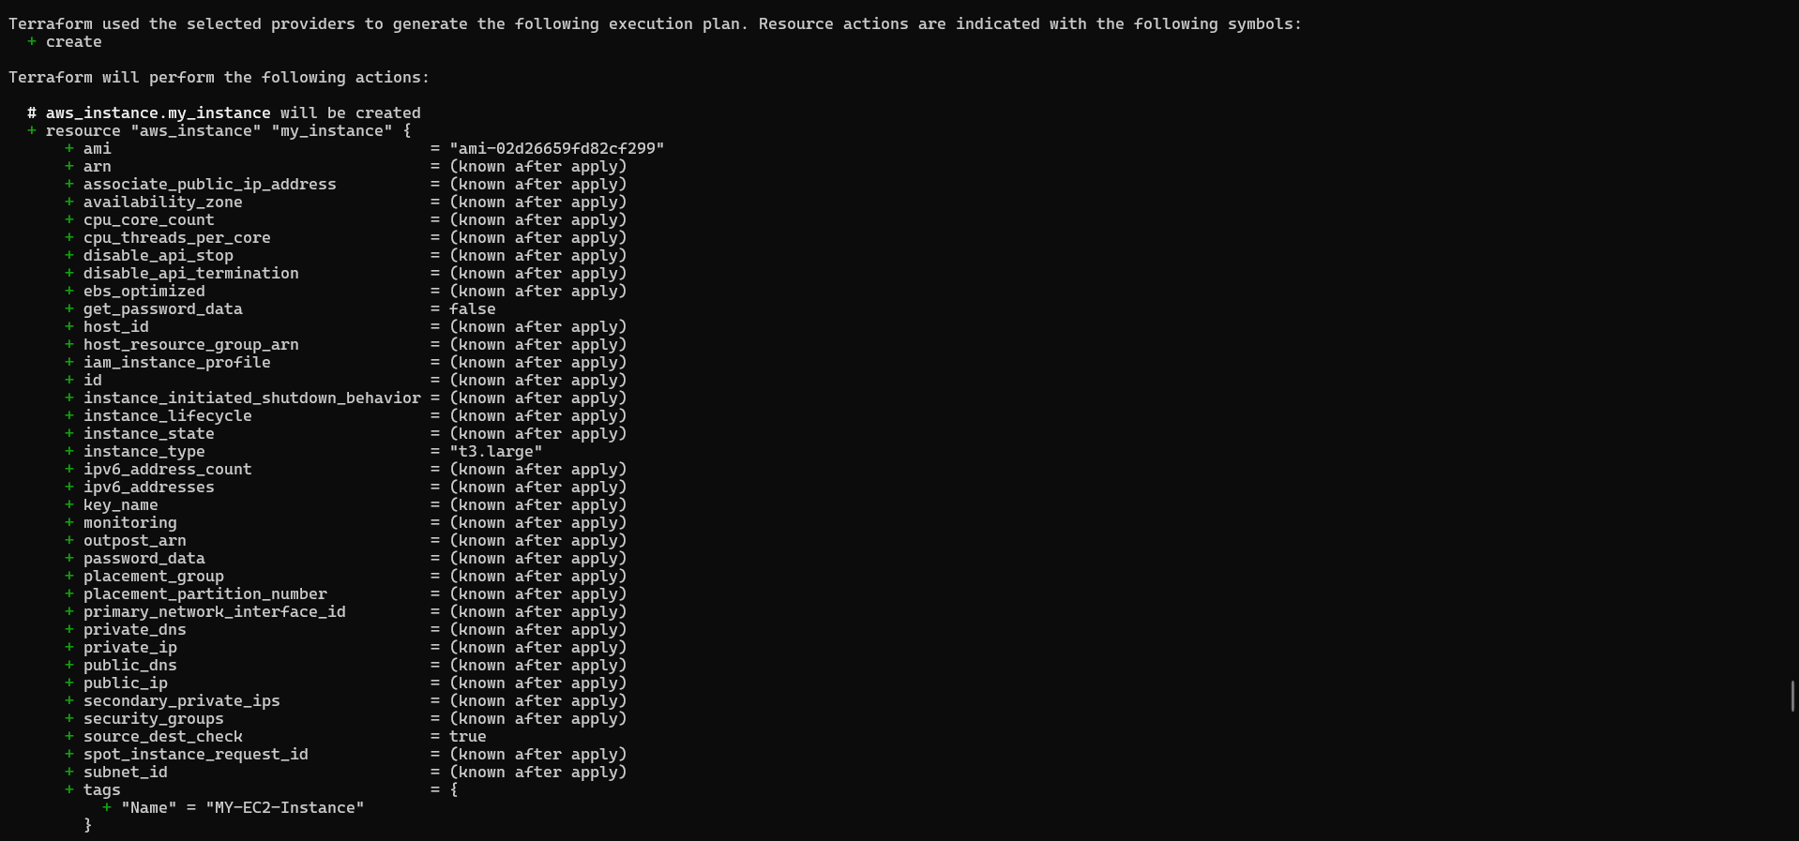
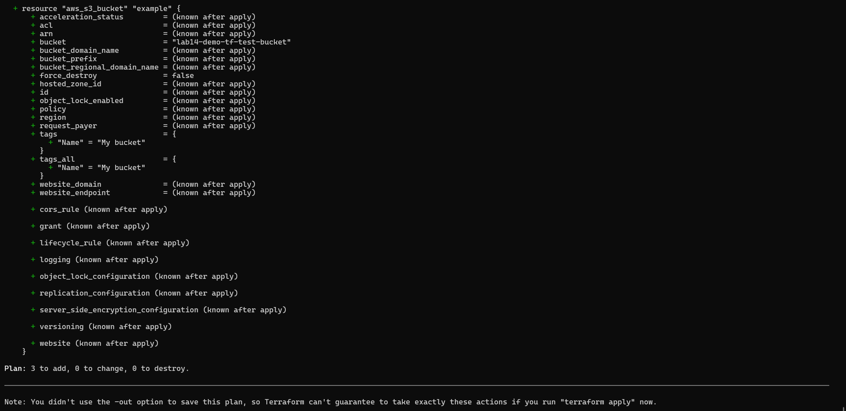
terraform apply -auto-approve

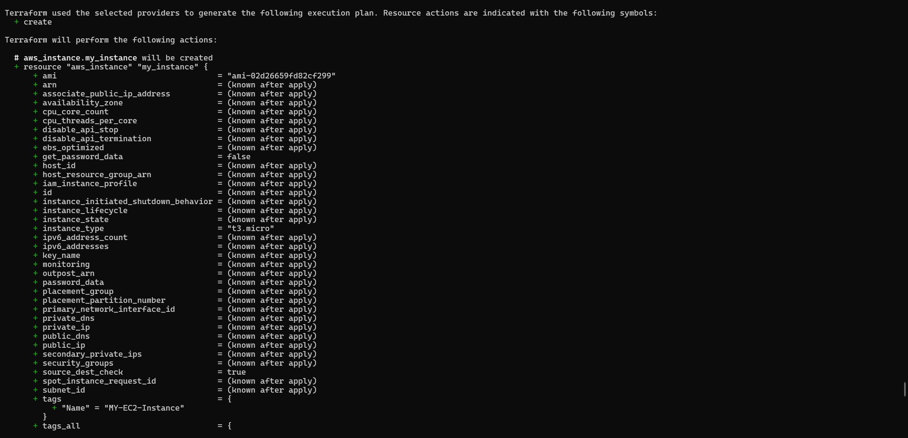

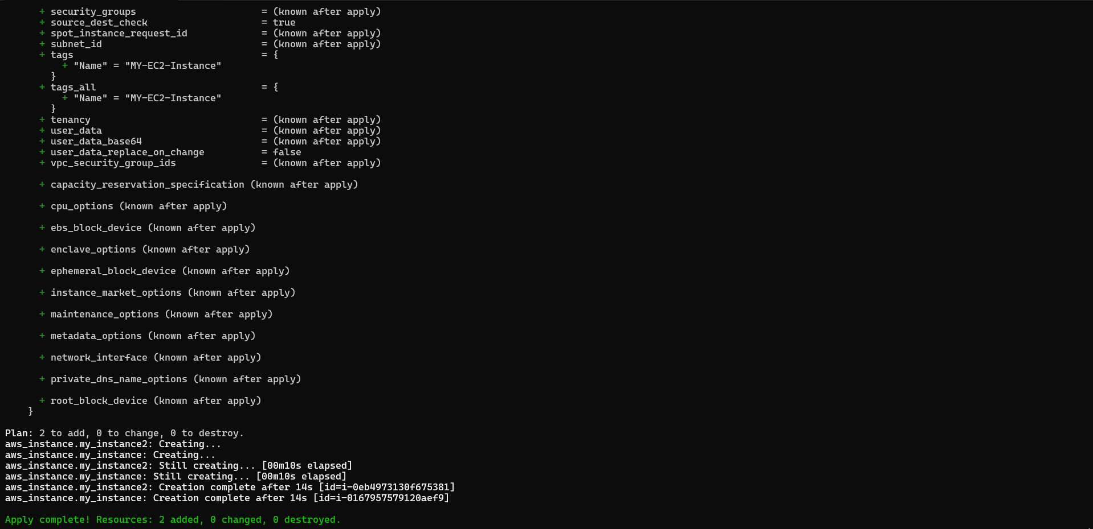
- Clean Up:
After testing, you can clean up resources.
terraform destroy
Confirm the destruction by typing yes.

Output:-

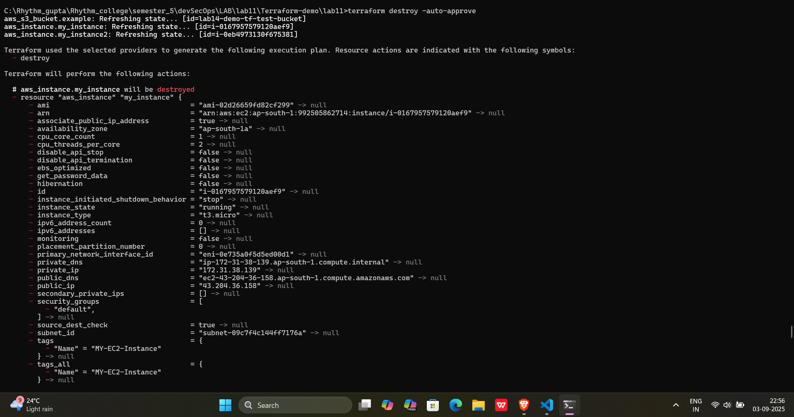

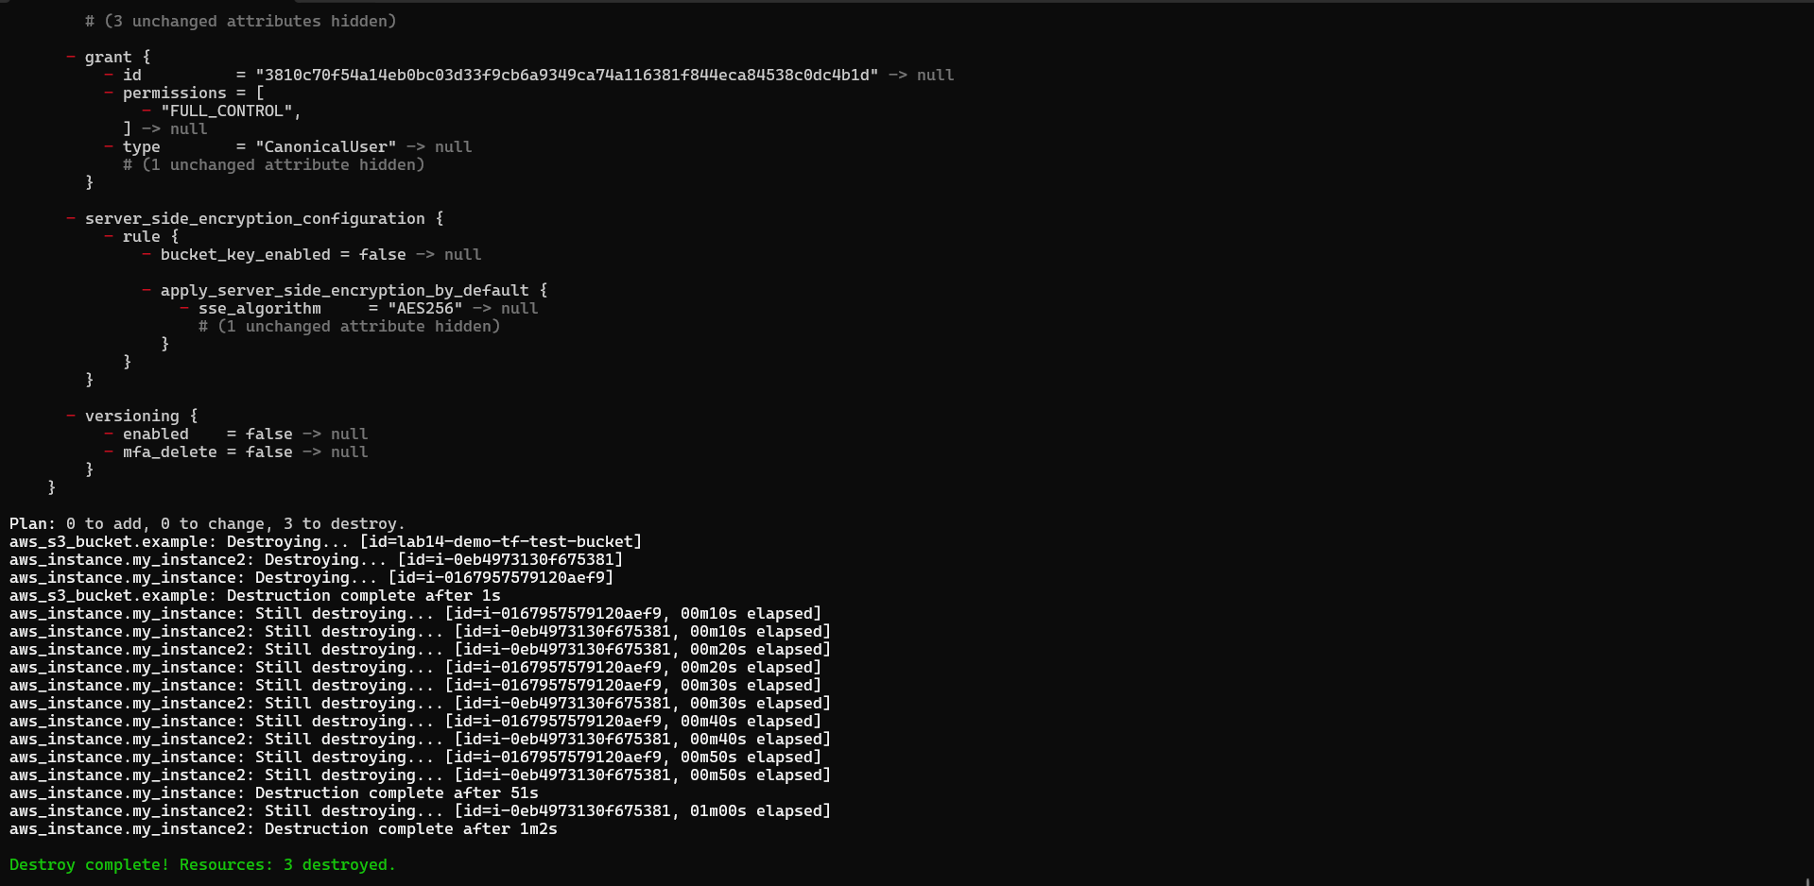
- Conclusion:
This lab exercise introduces you to Terraform variables and demonstrates how to use them in your configurations. Experiment with different variable values and overrides to understand their impact on the infrastructure provisioning process.

